

A

PROJECT REPORT

ON

“**ONSCREEN KEYBOARD**”

SUBMITED

TO

SAVITRIBAI PHULE PUNE UNIVERSITY, PUNE

FOR THE AWARD OF

MASTER OF COMPUTER APPLICATION

(MCA-I, SEM.-I)

BY

Ruturaj Uttam Gholap (Roll No 21249)

UNDER THE GUIDANCE OF

Prof. :Navanath Choudhari

SINHGAD INSTITUTE OF MANAGEMENT AND COMPUTER APPLICATION (SIMCA), NARHE, PUNE (AY. 2021-2022)

|  |  |  |  |  |
| --- | --- | --- | --- | --- |
|  | SINHGAD TECHNICALEDUCATIONSOCIETY’S  SINHGAD INSTITUTE OF  MANAGEMENT & COMPUTER APPLICATION  (Affiliated to Savitribai Phule Pune University & Appoved by AICTE)  ‘NAAC’ Accredited with ‘A’ Grade | | |  |
| S. No. 49/1, Off Westernly Bypass, Pune – Mumbai Expressway, Narhe, Pune – 411041, Tel : (020) 66831896 / 66831908 / 66831907  E-mail : director_mca_simca@sinhgad.edu Website : www.sinhgad.edu | | | | |
| Prof. M. N. Navale  M.E. (Elec), MIE, MBA  FOUNDER PRESIDENT | | Dr. (Mrs.) Sunanda M. Navale  B.A., P.P.M., Ph.D.  FOUNDER SECRETARY | Dr. Vilas Nandavadekar M.C.A., M.P.M., M.B.A., Ph. D.DIRECTOR, SIMCA - MCA | |

CERTIFICATE

This is to certify that, the project entitled “**ONSCREEN KEYBOARD**”, being submitted for the award of the degree of Master of Computer Application by her/him to Sinhgad Institute of Management and Computer Application affiliated to Savitribai Phule Pune University, Pune is the result of the original work completed by Ruturaj Gholap (21249) under the guidance of Prof.Navnath Chaudhari.

To the best of our knowledge and belief, this work has not been previously submitted by the award of any degree or diploma of Savitribai Phule Pune University or any other University.

PLACE: SIMCA(Narhe)

DATE:

Prof. Navanth Chaudhari Prof Ashwini Brahme Dr. Vilas Nandawadeker

Internal Guide Project Co-Ordinator Director SIMCA-MCA

External Examiner

|  |
| --- |
| **DECLARATION**  I, the undersigned hereby declare that the project titled “ ONSCREEN KEYBOARD”, being submitted for the award of degree of Master of Computer Application by me to Shinhgad Institute of Management and Computer Application(SIMCA) affiliated to Savitribai Phule Pune University is the result of an independent work carried out under the guidance of Prof.Navnath Chaudhari. , is my original work . Further I declare that this project has not been submitted to this or any Institution for the award of any degree.  PLACE: PUNE Student Name  DATE:  Ruturaj Gholap (Roll No 21249) |
|  |

**ACKNOWLEDGEMENT**

The project developed for the MCA was not possible without the persons and organizations that helped me in completing this. I am deeply grateful to all whose enthusiasm and energy transformed my vision of this study into reality.

I take this opportunity to thank my guide Prof.Navnath Chaudhari, project coordinator Prof. Ashwini Brahme and our Director Dr. Vilas Nandawadaker, for encouragement and guidance throughout the progress of this report.

Student Name

Ruturaj Gholap (21249)

**INDEX**

|  |  |  |
| --- | --- | --- |
| **Chapter**  **No** | **Details** | **Page No** |
| 1 | Introduction | **6** |
| 2 | Need of system | 7 |
| 3 | Scope of system | 8 |
| 4 | Technology Proposed for System | 9 |
| 5 | Software Requirement Specification | 10 |
| 6 | Diagrams   * System Flow Daigram | 12 |
| 7 | Coding Part | **12-15** |
| 8 | OUTPUT SCREEN | 16-18 |
| 9 | Apllication Design | 19 |
| 10 | Sailent Feachers | 20 |
| 11 | Limitation | 21 |
| 12 | Conclusion | **22** |
| 13 | Future Enhancement | 23 |
| 14 | Reference | 24 |

**INTRODUCTION**

The On Screen Keyboard System is very simple easy to handle.

We can using this application interact with computer same as physical keyboard.

We can type on any word process editor also handle all application of system.

The On Screen Keyboard is very useful for touch screen system.

**Need of System**

A keyboard is one of the primary input devices used with a computer. Similar to an electric typewriter, a keyboard is composed of buttons used to create letters, numbers, and symbols, and perform additional functions

When a physical keyboard is damaged, the virtual keyboard is the best solution for that.

# Following things show the need of a Software App:

1. Accuracy
2. Time Management
3. Error Free
4. Convivence in Learning process

# 

# **Scope Of System**

1. **Accuracy: -** The level of accuracy in the proposed system will be higher. All

operation would be done correctly and it ensures that whatever information of the stock being entered correctly.

1. **Reliability: -** The reliability of the proposed system will be high due to the reasons. The reason for the increased reliability of the system is that there would be proper storage of information.
2. **No Redundancy: -** In the proposed system utmost care would be that no information is repeated anywhere.
3. **Immediate retrieval of information: -** The main objective of this project is to provide for a quick and efficient retrieval of information. Any type of Information would be available whenever requires it.
4. **Easy to operate: -** The system should be easy to operate and should be such that it can be developed within a short period of time.
5. **User friendly Interface: -** Easy and Friendly User Interface.

# **Technology Proposed For Project**

# Hardware and Software Requirement:

A major element in building system is selection of compatible hardware & software. Hardware selection they begin with requirements analysis following by a request for proposal, evaluation & validation, post installation review.

While selecting the software various criteria is considered such as reliability (gives consistent results), functionality (function to standards), capacity (satisfies volume requirements), flexibility (adapts to changing needs), usability (user friendly), security (to prevent unauthorized access), performance (capacity to deliver as expected), serviceability (good documentation), minimal cost (affordable for intended application).

**Software Requirements:-**

1. Any Windows Version XP
2. Vista or on words.
3. JDK 1.8
4. latest version, Jcreater or Netbeans 6.1. or Sublime Text

**Hardware Requirement:-**

1. 1GB or more RAM.

2. Any Pentium processor.

3. Hard disk 500 or more

**Software Requirements Specification (SRS)**

Once the analyst has performed all the above mentioned activities, all the requirements are to be systematically organized in the form of an SRS document. The SRS document usually contains all the user requirements in an informal form for the ease of understanding.

An SRS document clearly documents the following aspects of a system:

* Environmental characteristics
* Hardware
* Software
* Functional Requirements
* Non-Functional Requirements

**Functional Requirements:**

When you press a key, it presses a switch, completing the circuit and allowing a tiny amount of current to flow through. The mechanical action of the switch causes some vibration, called bounce, which the processor filters out.

**System Flow Daigram**

**

**Coding Part**

**import java.awt.*;**

**import java.awt.event.*;**

**import java.io.File;**

**import java.io.IOException;**

**import java.io.InputStream;**

**import java.net.URL;**

**import java.util.Locale;**

**import javax.sound.midi.InvalidMidiDataException;**

**import javax.sound.midi.Soundbank;**

**import javax.sound.midi.spi.SoundbankReader;**

**import javax.swing.*;**

**import javax.swing.plaf.*;**

**import javax.swing.text.Caret;**

**class Osk extends JFrame implements ActionListener**

**{**

**Robot robo;**

**JButton b0[],b1[],b2[],b3[],b4[],b5[],tab,shift,caps,shift1,aa;**

**JButton home,end,delete,insert,page_up,page_down;**

**int wn=0,al=0,ct=0;**

**String s0[]={"esc","F1","F2","F3","F4","F5","F6","F7","F8","F9","F10","F11","F12","Prt_sc","Scr_lk","Break"};**

**String s1[]={"`","1","2","3","4","5","6","7","8","9","0","-","=","<-"};**

**String s2[]={"q","w","e","r","t","y","u","i","o","p","[","]","\\"};**

**String s3[]={"a","s","d","f","g","h","j","k","l",";","'","Enter"};**

**String s4[]={"z","x","c","v","b","n","m",",",".","/","^"};**

**String s5[]={"ctrl","WIN","alt"," ","alt","prt","ctrl","<<","v",">>"};**

**String sym1[]={"~","!","@","#","$","%","^","&","*","(",")","_","+"};**

**String sym2[]={"{","}","|"};**

**String sym3[]={":","\"",};**

**String sym4[]={"<",">","?"};**

**public int cap=0,adj,shft=0,cnt=0,flag=0;**

**public int sss=0;**

**boolean bl=false;**

**Osk(String str)**

**{**

**super(str);**

**this.setLayout(null);**

**try**

**{ UIManager.setLookAndFeel("com.sun.java.swing.plaf.windows.WindowsLookAndFeel");**

**}**

**catch(Exception e)**

**{**

**}**

**allbutton();**

**splbtn();**

**}**

**public void actionPerformed(ActionEvent ae)**

**{**

**try**

**{**

**robo=new Robot();**

**}**

**catch(Exception e){}**

**if(ae.getSource()==caps)**

**{**

**if(cap==0)**

**{**

**cap=1;**

**upper();**

**flag=1;**

**robo.keyPress(KeyEvent.VK_CAPS_LOCK);**

**robo.keyRelease(KeyEvent.VK_CAPS_LOCK);**

**}**

**else**

**{**

**cap=0;**

**caps.setBackground(null);**

**lower();**

**flag=0;**

**robo.keyPress(KeyEvent.VK_CAPS_LOCK);**

**robo.keyRelease(KeyEvent.VK_CAPS_LOCK);**

**}**

**}**

**else if(ae.getSource() == shift||ae.getSource() == shift1)**

**{**

**if(shft==0 && cap==0)**

**{**

**robo.keyPress(KeyEvent.VK_SHIFT);**

**bl=true;**

**upper();**

**shiftm();**

**shft=1;**

**}**

**OUTPUT SCREEN**

**1 Testing Alphabets:**

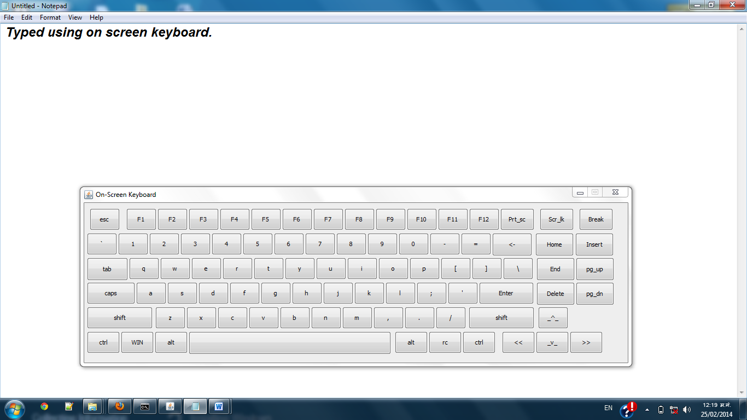

**2 TESTING NUMBERS:**

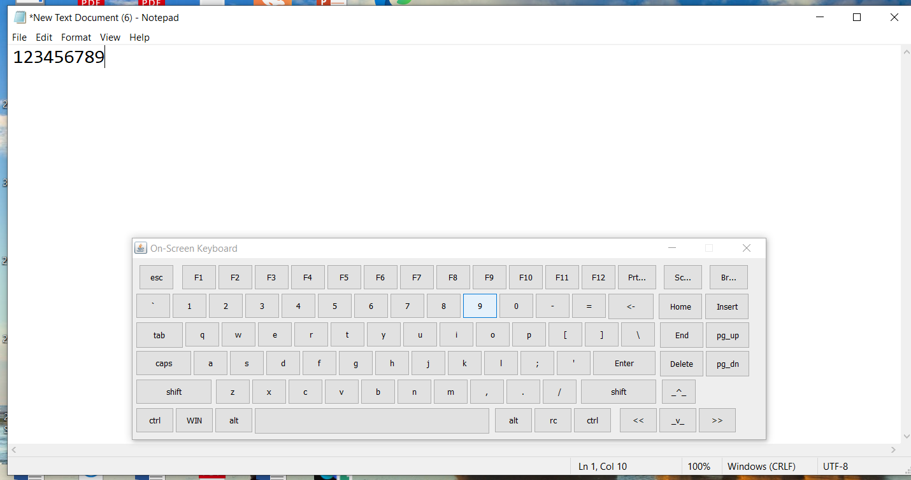

**3 TESTING SYMBOLS:**

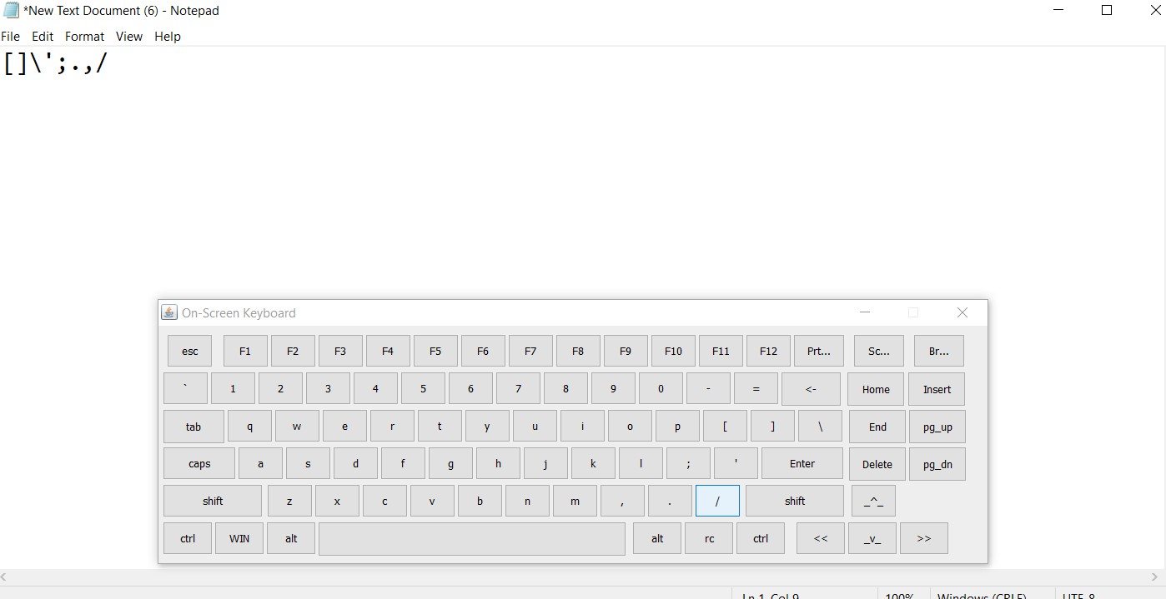

**Application Design**

**Front-end selection:**

An important issue for the development of a project is the selection of suitable front-end. When we decided to develop the project we went through an extensive study to determine the most suitable platform that suits the needs of the organization as well as helps in development of the project.

The aspects of our study included the following factors.

1. It must have a graphical user interface that assists employees that are not from IT background.

2. Scalability and extensibility.

3. Flexibility.

4. Robustness.

5. According to the organization requirement and the culture.

6. Must provide excellent reporting features with good printing support.

7. Platform independent.

8. Easy to debug and maintain.

9. Event driven programming facility.

Satisfying the above needs we used JAVA language.

**Salient Feachers**

Structure:

Simple structure same as physical QWERTY

Structure.

the screen are well designed and self explanatory, with information specified when ever required .this makes user interaction easy and fast

Tedious and complex task are simplified that user can easily use this application.

***How to Start..?***

Simple to start just open application and set cursor to specified location where you want to do work then press the button using mouse.

Or touch the screen if support it.

**Limitation**

* This Application is slow for working.
* It will JDK 1.5 or onwords.

* This Application has requireMouse to handle.

# **Conclusion**

The Application quality depends upon the phases included in the system. An application should be easy to operate & understand. A high-Quality Application product satisfies the user requirements regarding design specification & maintains flexibility as well. These aspects are accomplished in developing this Particular Application “**ONSCREEN KEYBOARD**”.

There is special section for all users where they can easily access the onscreen keyboard

The software is-

* User Friendly- The software is totally user friendly & easy to operate & understand.
* Duplicity- As data is completely normalized, so that no duplicate entries exist
* Menu driven- This software is totally menu driven for the best result.

**Future Enhancement**

* In future we will provide with Num-Pad.
* Implementation of Sound also possible.
* Implementation of Advance Graphics.
* Implementation of Look and Feel.
* We will provide with more validation.

**References**

For the completion of the “On Screen Keyboard” and documentation we have Referred the following

• Books

JAVA-The complete Reference :HerbertSchildt.

JAVA Black book :Dr.R.NageshwarRao

* Web Site

[www.tutorialspoint.com](http://www.tutorialspoint.com/)

[www.w3schools.com](http://www.w3schools.com/)

[www.tutorialsteacher.com](http://www.tutorialsteacher.com/)

[www.YouTube.com](http://www.youtube.com/)

• Internet